Query 7:

---------

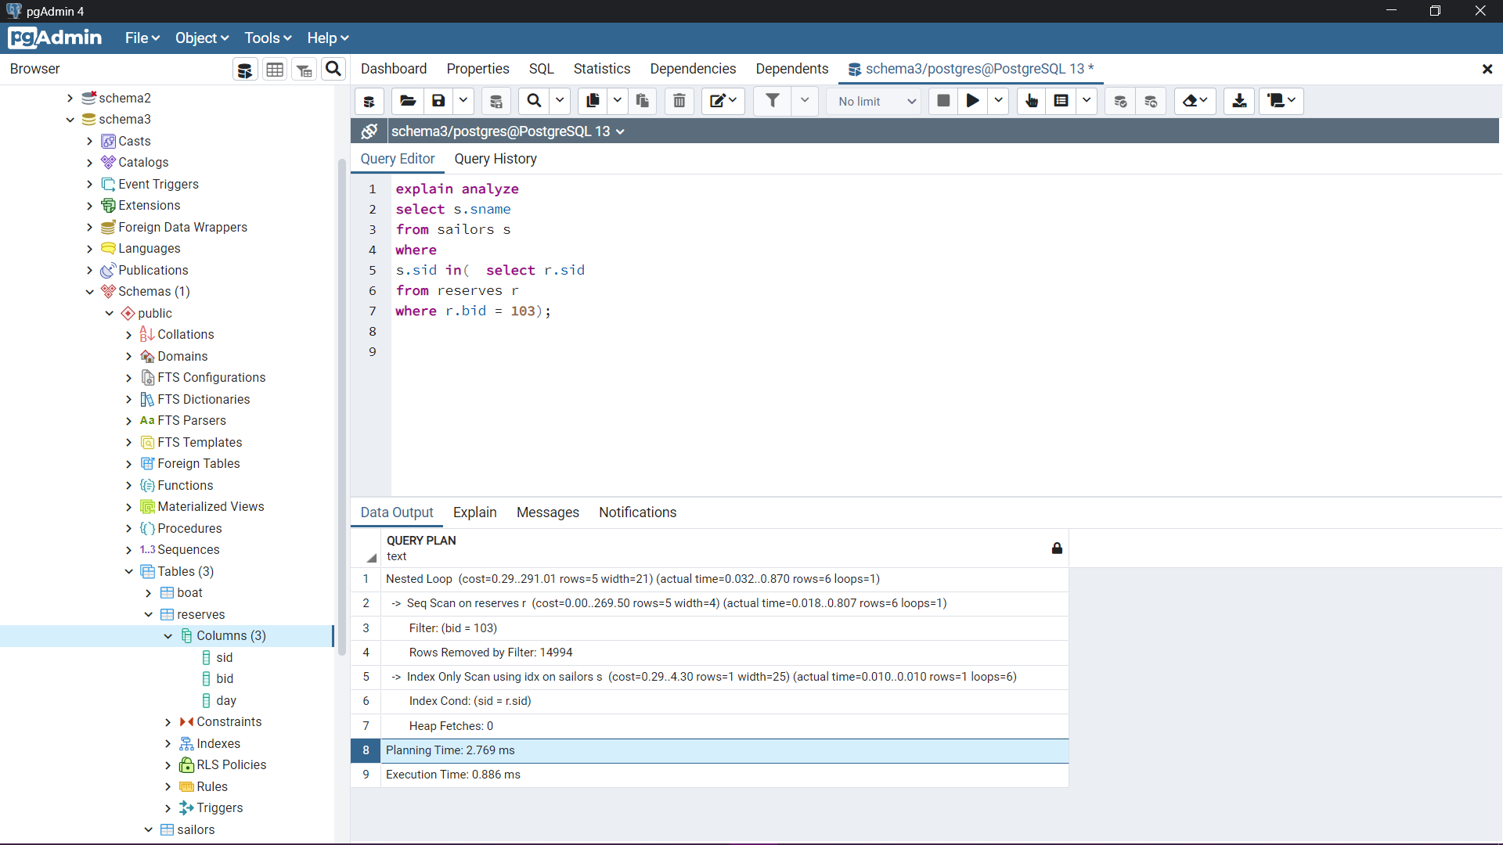

First step: Analyze sailors, Analyze reserves to collect statistics on both tables

“select * from pg_stats where tablename = reserves”

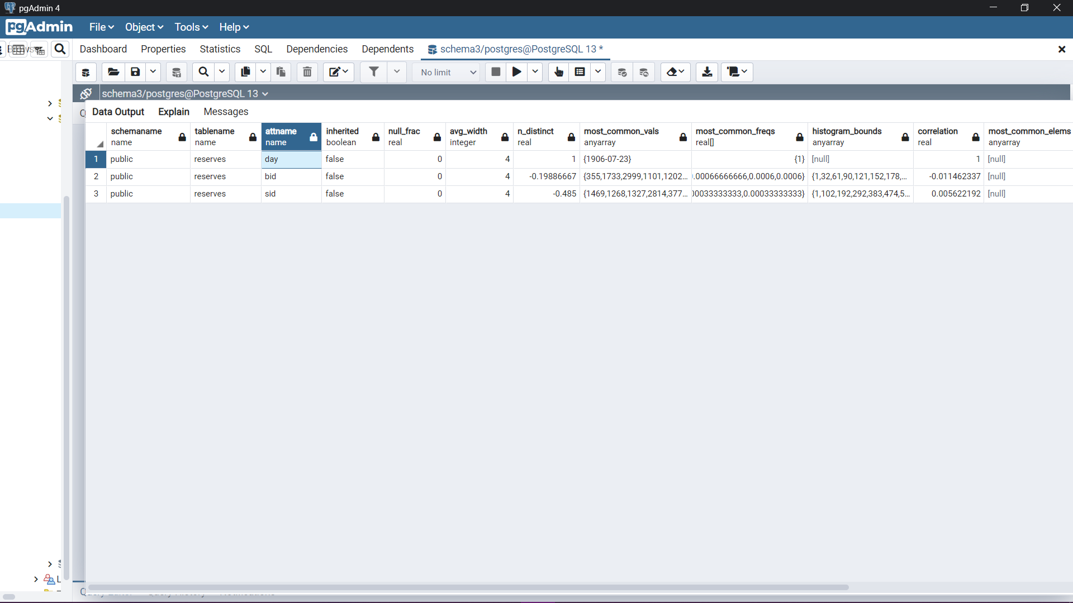

“select * from pg_stats where tablename = 'boat'”

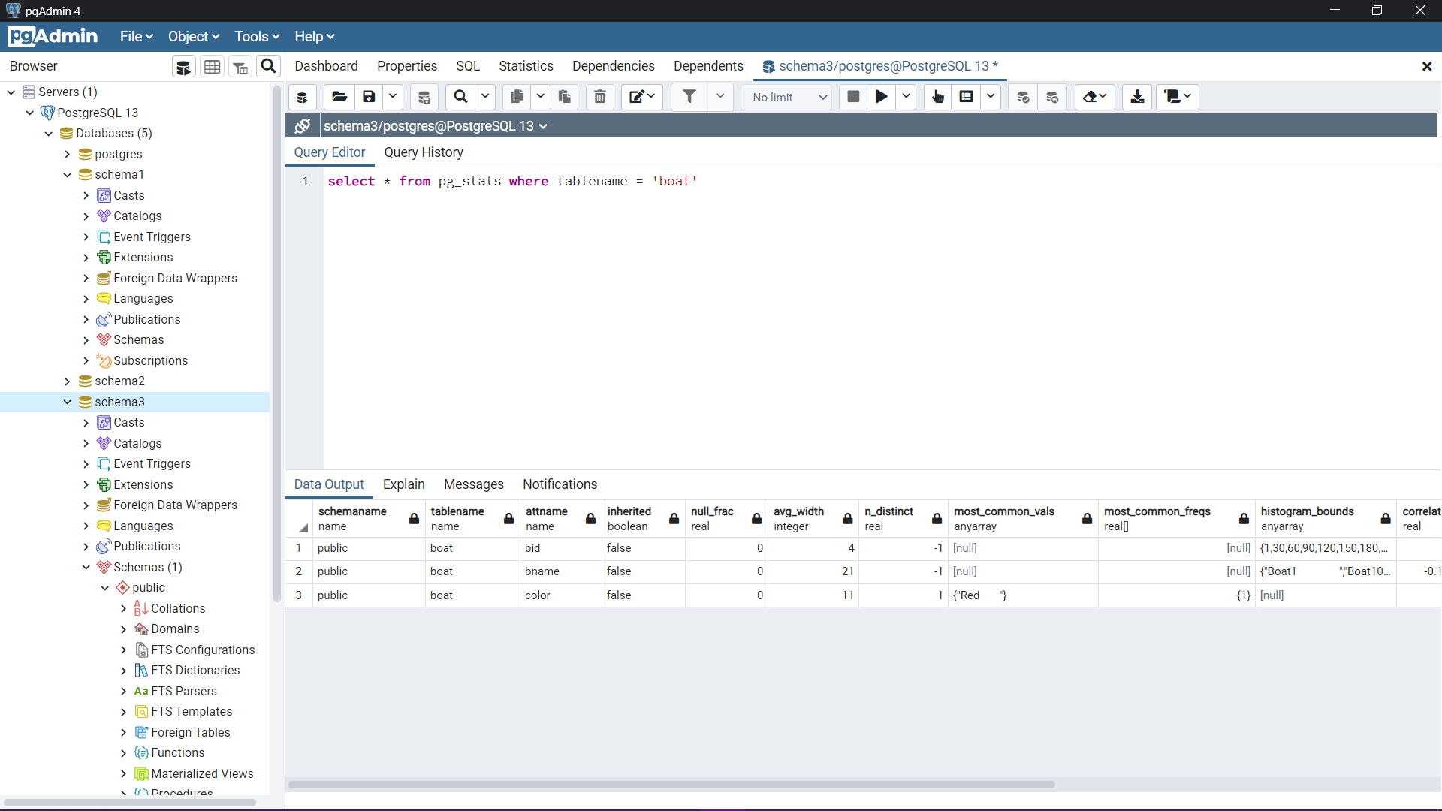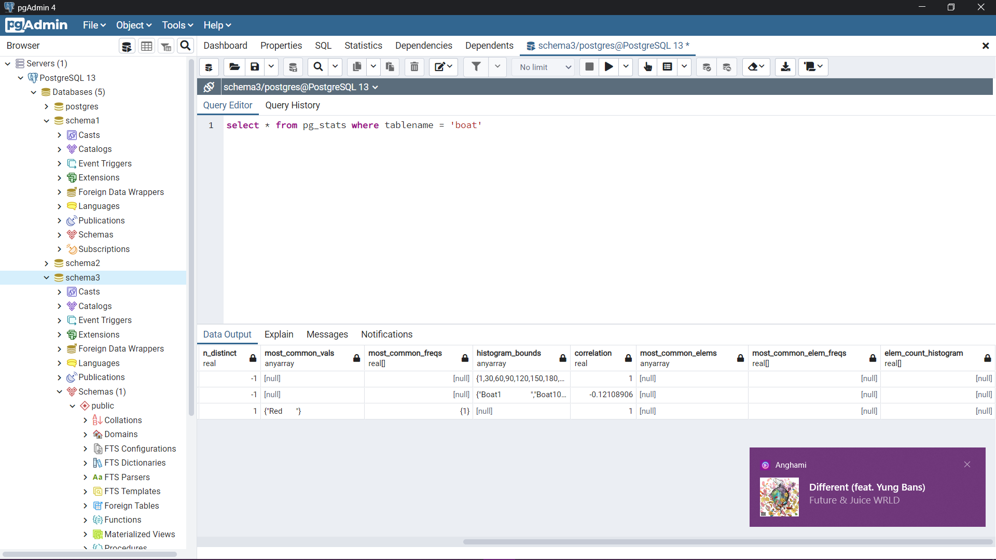

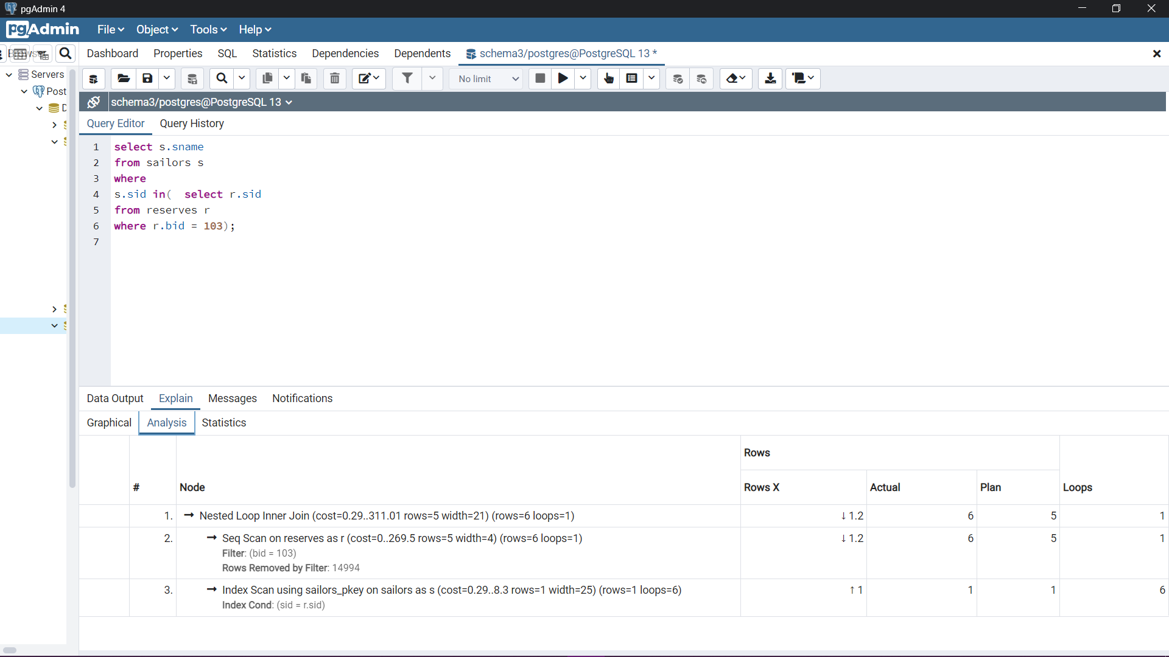

"Planning Time: 0.378 ms"

"Execution Time: 1.252 ms"

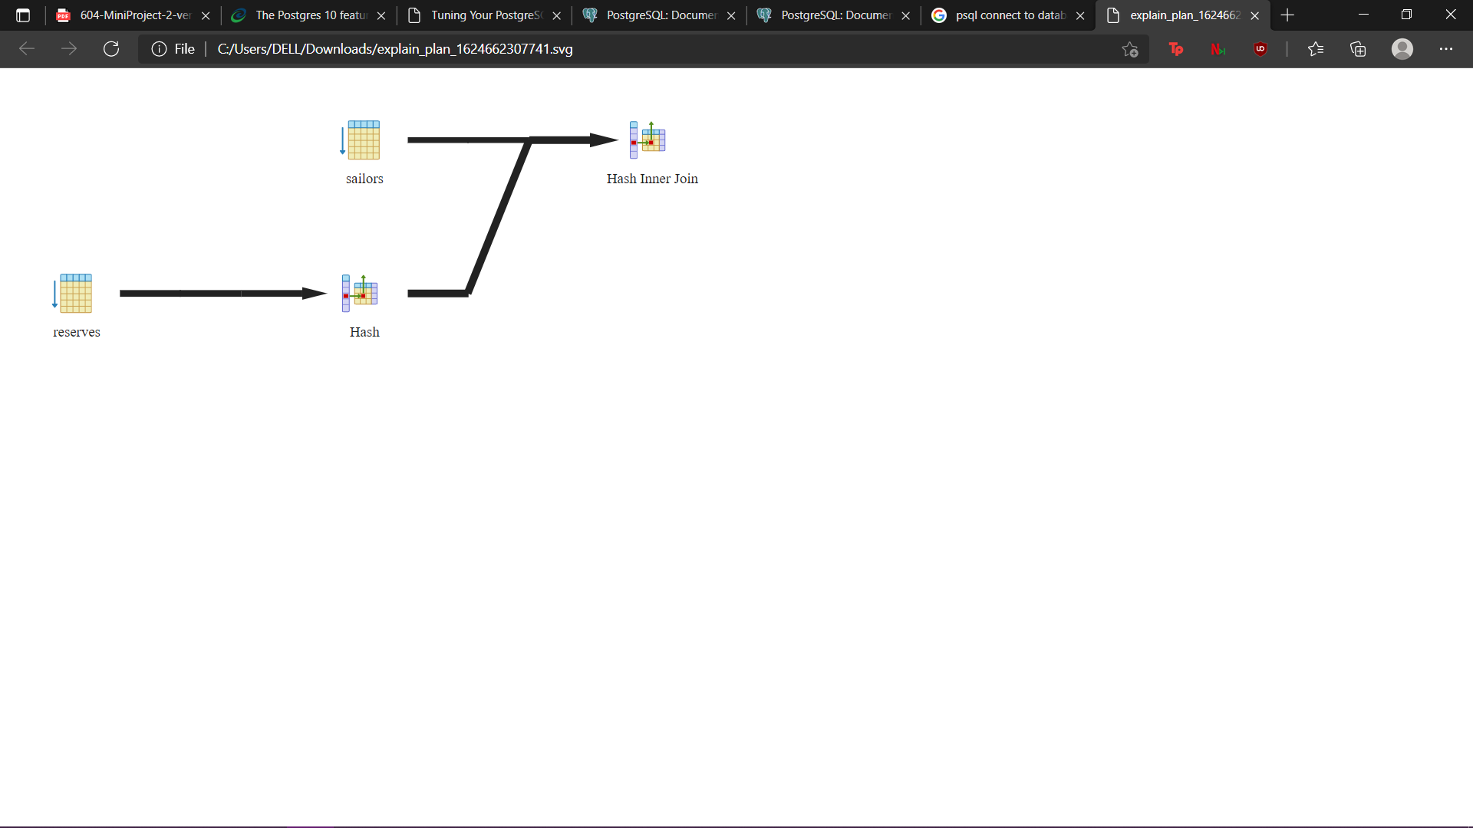

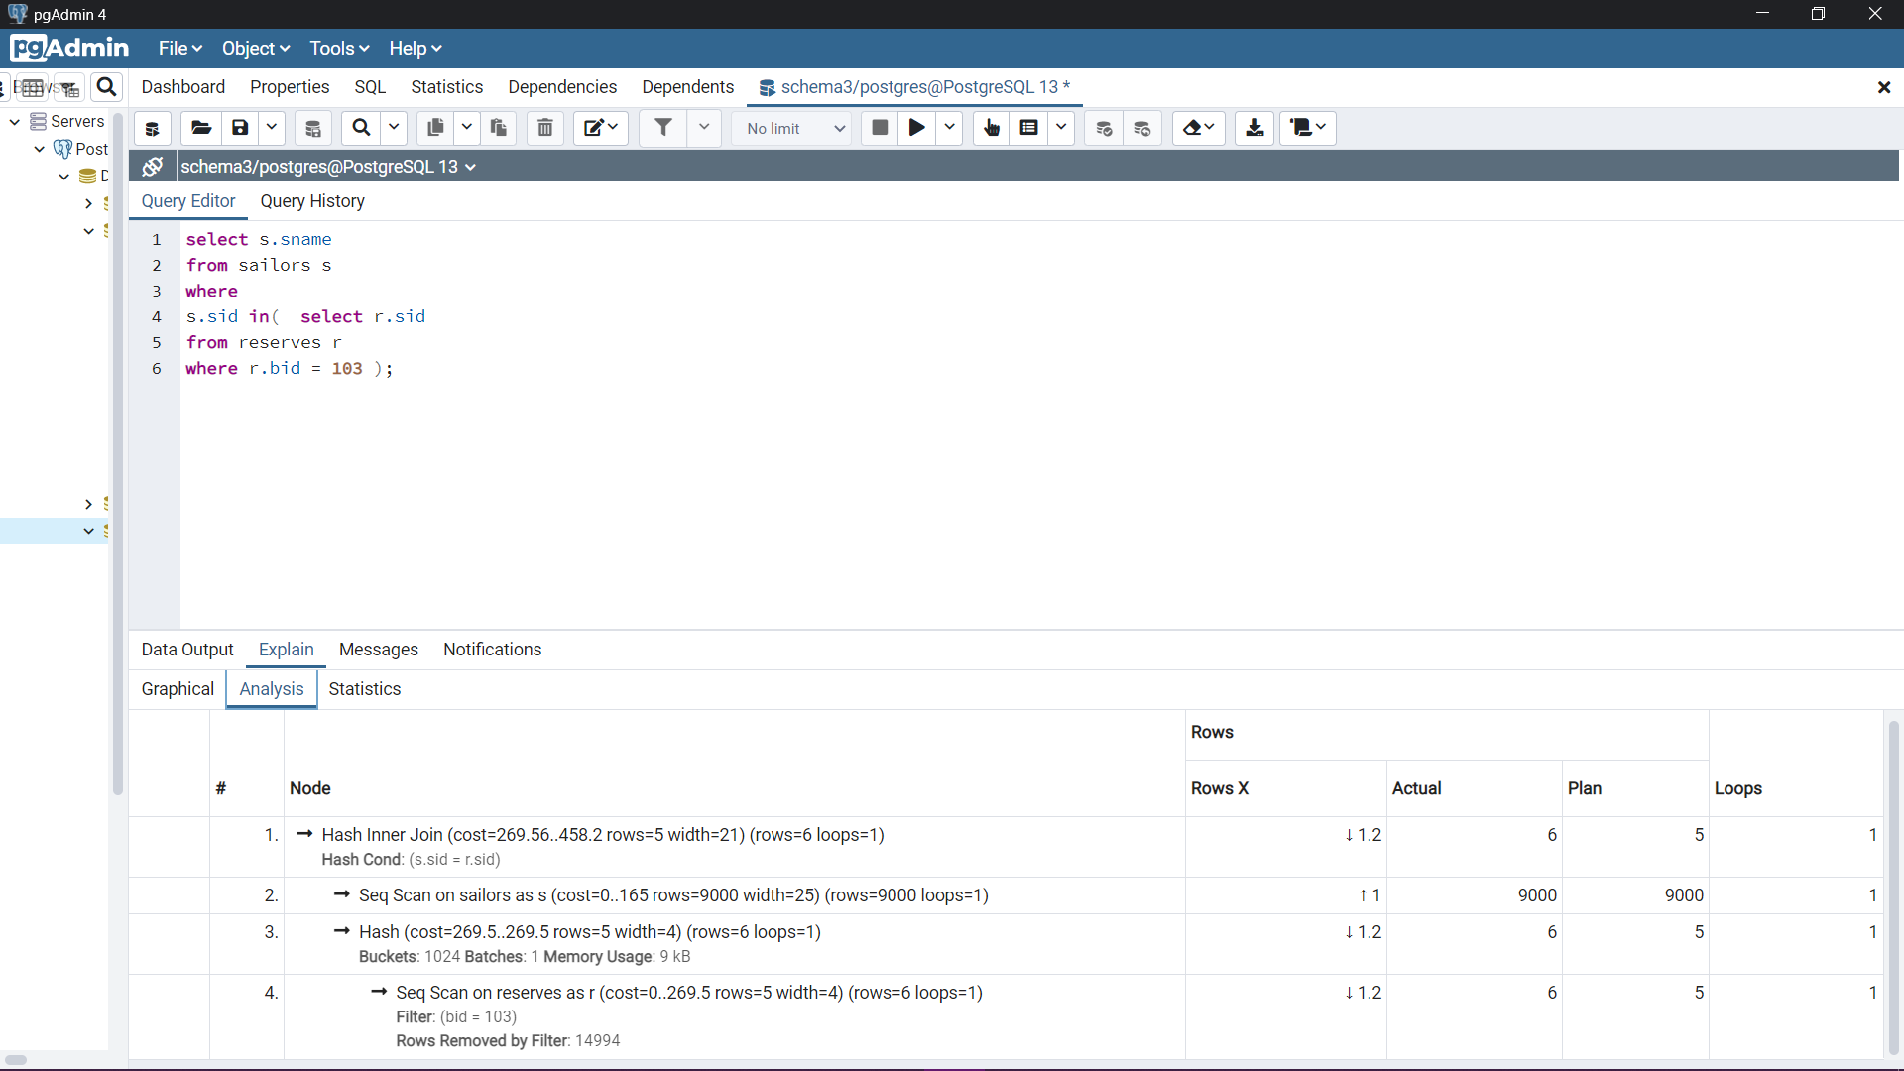

After “SET enable_nestloop=false”

"Planning Time: 0.352 ms"

"Execution Time: 6.027 ms"

